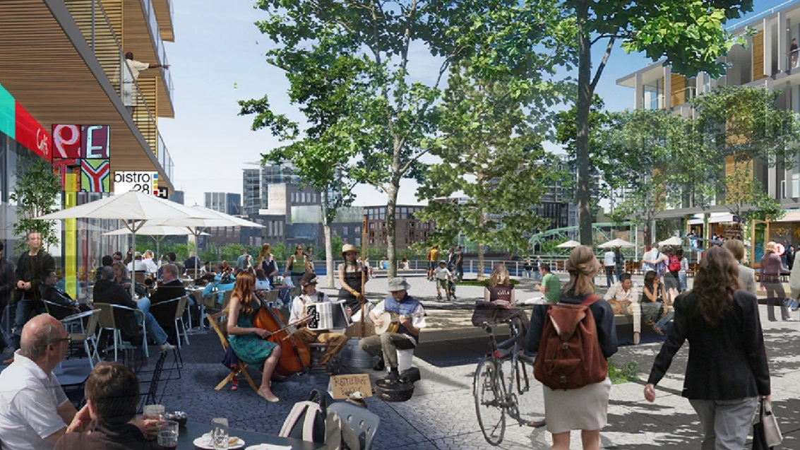
The Town of Cobourg Planning & Development Services Division would like to update key stakeholders and interested parties of the Sustainable Neighbourhood Master Plan project for the Tannery District (see Primary Study Area map below) and advise of an upcoming public input session.  About the Study  The objective of the Sustainable Neighbourhood Master Plan project is to develop a comprehensive plan to achieve a healthy, vibrant and sustainable neighbourhood in the Tannery District. The Sustainable Neighbourhood Master Plan will build on the goals of the Official Plan to establish a vision for the Tannery District and provide the policy, governance and implementation framework to guide future development and decision-making. In addition, building on the Tannery District Community Improvement Plan (CIP) and design charrette process undertaken in 2009, this project aims to develop a long range Sustainable Neighbourhood Master Plan for the Tannery District which is on the “cutting edge” of sustainability.  The Consultant Team  The Town of Cobourg has retained a consulting team led by Fotenn Planning + Design (www.fotenn.com) and Urban Equation (www.urbanequation.ca) to prepare the Sustainable Neighbourhood Master Plan. Fotenn is an award-winning urban design, planning, and landscape architecture firm with offices in Toronto, Ottawa, and Kingston. Urban Equation is a sustainability-focused consulting practice providing business advisory and technical services with offices in Ottawa and Toronto.  Primary Study Area  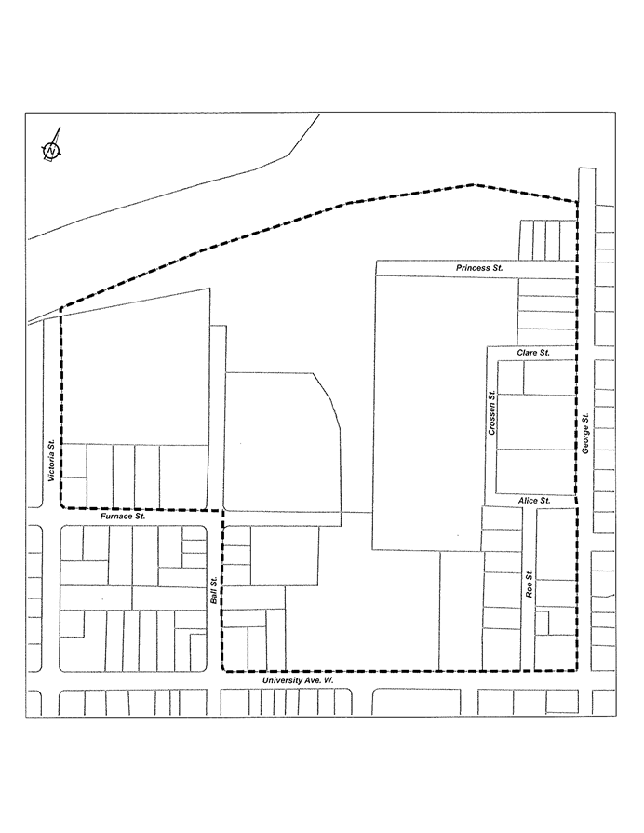  Victoria Street  George Street  Furnace Street  University Avenue West  CN/CP Railways |  | The Process  The Sustainable Neighbourhood Master Plan commenced in April, 2017, with completion anticipated for June, 2018. The study will be completed in three phases, including:  - Phase 1 - Data Collection & Background Review, with Open House/Workshop (May 2017 to November 2017)  - Phase 2 - Policy Formulation, with Open House/Workshop (December 2017 to April 2018)  - Phase 3 - The Sustainable Neighbourhood Master Plan, with Council Public Meeting (May 2018 to June 2018)  The implementation of this project is made possible in part through funding from the Federation of Canadian Municipalities Green Municipal Fund.  How Can You Participate?  The Town of Cobourg invites key stakeholders and interested parties to attend an Open House/Interactive Workshop and help shape the long term transformation of the Tannery District into a model sustainable neighbourhood.  When: Wednesday, March 28, 2018  6:00 pm – Open House  6:30 pm – Presentation  7:00 pm – Workshop  Where: Columbus Community Centre  232 Spencer Street East, Cobourg  Please join us for an update to the project process and an opportunity to actively participate and provide your ideas for the future of the Tannery site.  Updates  A special municipal website has been developed for the Tannery District Sustainable Neighbourhood Master Plan project – see https://www.cobourg.ca/en/business-and-development/Tannery-District.aspx .  Interested parties may also contact the following person for further details.  Glenn J. McGlashon, MCIP, RPP  Director of Planning & Development  Planning & Development Division  Victoria Hall -- 55 King Street West  Cobourg, Ontario, K9A 2M2  e. gmcglashon@cobourg.ca  t. 905.372.1005

