Welcome!

Town of Cobourg
Urban Forest Management Plan
Second Public Meeting

25 October 2017
4:00 to 7:00 p.m.
Cobourg Community Centre – Spoolon Room
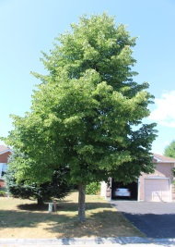
The proposed strategic directions for management of Cobourg’s urban forest over the next 20 years are organized from a high-level vision description through statements that provide more specific direction – goals, then objectives to meet the goals, ending with a set of specific forest management activities. The principles or Town commitments for how all the work will be done are aligned with other Town initiatives and apply to fulfillment of all the other statements.

Principle: Statement that articulates the Town values and commitments and overall basis for urban forest management.
Vision Statement – desired state in 20 years (and longer term – 50/100/150 years. The statement should be concise, visual, inspiring, far-reaching, memorable, long-lasting.
Goals: Action statement of key strategic directions required to meet the vision.
Objectives: break each of the goals into several tasks which are articulated as measurable results, outcomes (statement of the end state to be achieved) or products that achieve part or all of a goal
Targets are expressed as specific numeric objectives that represent end state conditions to achieve
Actions: Specific tasks that work together to meet the goals and achieve the desired outcomes
Principles
Vision
Actions / Strategies

Vision:
Cobourg will be a community in the Forest

- Recognized, valued, and a prized community asset of which residents are proud
- Lush and continuous, tree cathedrals, tree-lined streets, and looks and performs like a forest
- Well managed, with long-term planning of 100-150 years to achieve the desired forest health, composition and cover
- Contributes to community sustainability – the urban forest provides environmental, social, cultural & economic benefits
- Minimal conflict with utilities
- Predominantly native species, evolving to be resilient to climate change while taking soil and location into consideration
- The urban forest’s look and function reflects known pre and early settlement characteristics of Cobourg
- The whole community works together in stewardship/care of the Town’s urban forest

Principles
- Proactive management
- Cost-effective urban forest management program
- The urban forest will provide connections and corridors for wildlife and people
- Community outreach and engagement is key to achieving the urban forest vision
- Partnerships are key
- Right tree in the right place
- Active management of the urban forest
- All trees, shrubs and plants comprise the urban forest
- Establish a balance between human uses and ecological needs of the publicly owned urban forest
Goals
- The urban forest will be lush, diverse, healthy & resilient
- The urban forest will contribute to community sustainability
- The Town of Cobourg community will understand the urban forest’s importance and will be actively involved in its care
- The Town’s approach to management of trees on public lands will meet urban forest & community needs
- The Town will support residents and businesses in the stewardship of trees on private property

Goal #1: The urban forest will be lush, diverse, healthy and resilient
  - Native species are preferred in the planting of new trees, with hardy non-native species established in hostile urban locations
  - Greater native tree diversity
  - Carolinian tree species are introduced to improve urban forest resilience to climate change
  - More trees and an expanded tree canopy throughout the Town
  - Biodiverse and resilient enough to adapt to future changes and challenges; performs as an ecosystem
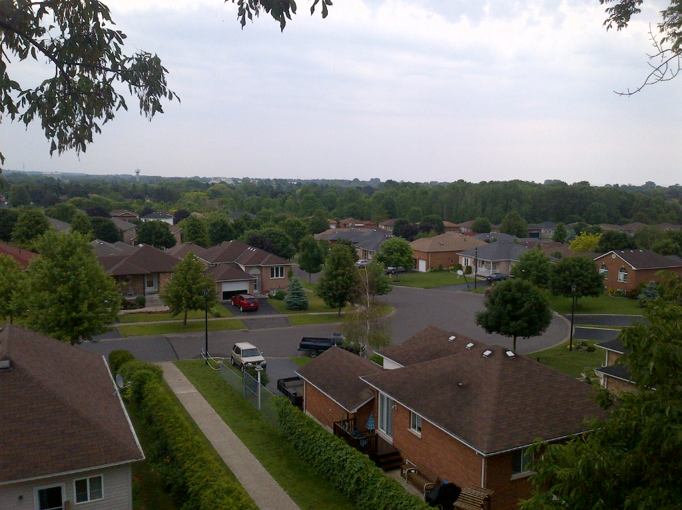
  - Consider a target of 35-40% canopy cover, to be achieved by about 2050
Goal #2: The urban forest will contribute to community sustainability
- Provides vitality, colour, variety and sense of life
- Provides shade, saves energy for homes and businesses
- Connected to Cobourg’s human and natural history – large, majestic trees, tree cathedrals and tunnels; apple orchards; more trees/vegetation along the Lake Ontario shoreline and along creeks; tree-lined Town entrances and gateways; naturalized streetscapes
- Connected and positive contribution to the regional natural heritage system
- Cobourg will be a welcoming natural environment, a place where people wish to live, where families feel connected
- Cobourg provides a ‘go-to’ destination for visitors and is a place to explore and experience nature.
- Parks will be connected to the urban forest, providing open spaces and treed areas for community needs
- The urban forest will provide ecological benefits - oxygen, erosion control, cooling, improved air quality, carbon sink, healthy soil, increased property value, enhanced aesthetics, noise reduction
- The urban forest adds to residents’ quality of life
Goal #3: The Town of Cobourg community will understand the urban forest’s importance and will be actively involved in its care
- Residents will know the value and benefits of the urban forest
- The Town will manage the forest through partnerships
- The urban forest contributes to Town food security
Goal #4: The Town’s approach to management of trees on public lands will meet urban forest and community needs
- The right tree is in the right place; there are limited conflicts with other infrastructure
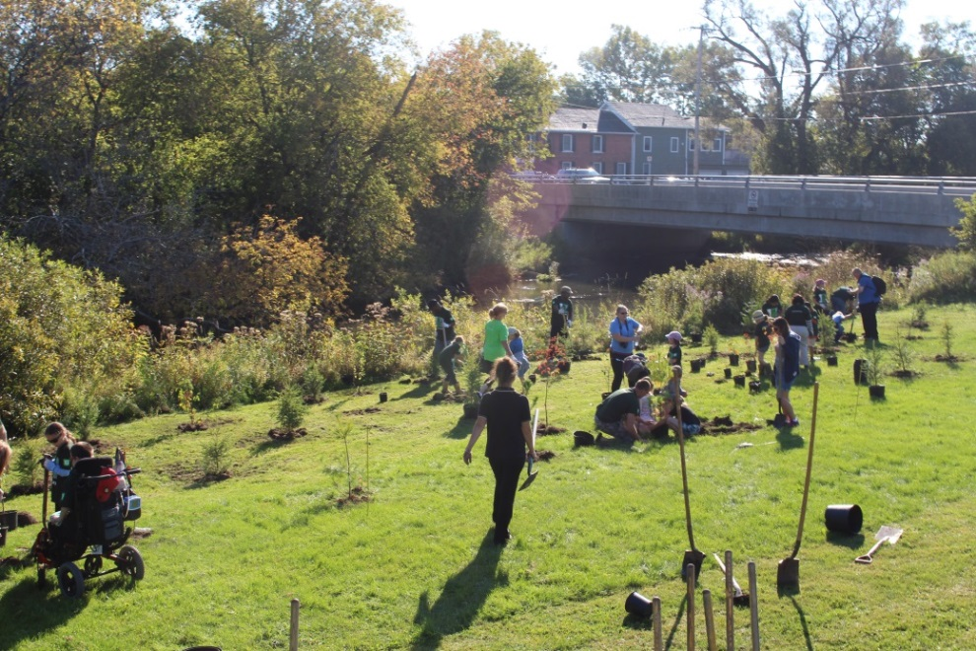
- The urban forest will be managed according to the life cycle of trees – 50 to 100 to 150 years
- Trees receive attention at the right time
- A risk management program is in place
- Make the best use of spaces and resources available for establishment and care of trees
- Adequate resources are available for timely and effective care of the Town’s urban forest
- Establish a baseline situation for the urban forest at a Town & neighbourhood level; monitor progress regularly
- Work will be completed in the short term to establish the desired urban forest (cover) so that urban forest management is a maintenance program in 50 years
- The Town will integrate wildlife habitat needs into its approach to urban forest management
Goal #5: The Town will support residents and businesses in tree stewardship on private property
- Encourage & support tree planting on private property
- Enhance site development guidelines to plant more trees
- Consider compensation program for trees removed from private property; direct funds to Town urban forest management; increase replacement ratio from 2:1 to 6:1
- Encourage tree oases in parking lots and other areas

Action | *Resource Needs | Timing
- Establish a Tree Planting Plan to increase forest cover for the Town and on a Neighbourhood Basis | Within Existing Resources | 2018 and ongoing
- Enhance the Tree Maintenance Program to include regular pruning, tree data update, tree care | Existing + Additional Resources | 2018-2020 and ongoing
- Proactively Manage Tree Risks such as diseases, pests, invasive species, dying limbs & trees, drought | Existing + Additional Resources | 2018-2020 and ongoing
- Establish a Community Stewardship Program that informs & involves residents and businesses in tree care | Existing + Additional Resources | 2019-2020 and ongoing
- Implement a Funding Strategy (grants, sponsorships, bequests, volunteers, compensation for removal of trees) that enables the Town to well manage trees | Existing + Additional Resources | 2018-2019 and ongoing
- Update the Tree Protection By-Law to obtain increased funds for tree planting and removal associated with new development; monitor and report on progress | Within Existing Resources | 2018-2019 and ongoing
- Establish a Town Heritage Tree Program to recognize and conserve important trees | Additional resources | 2018-2020/ongoing
- Clear Governance: Town Parks leads urban forest management and works closely with Partners to access available resources for efficient management through the CAO’s shared initiatives, Planning & Sustainability Advisory Committee, County, GRCA, Utility Companies, Community Groups and others | Existing + Additional Resources | 2018-2020
- Integration with Other Town Initiatives: Link urban forest management to other initiatives, i.e. Asset Management, Town Heritage, Parks Planning, development review, etc. | Existing Resources | 2017-2018 and ongoing
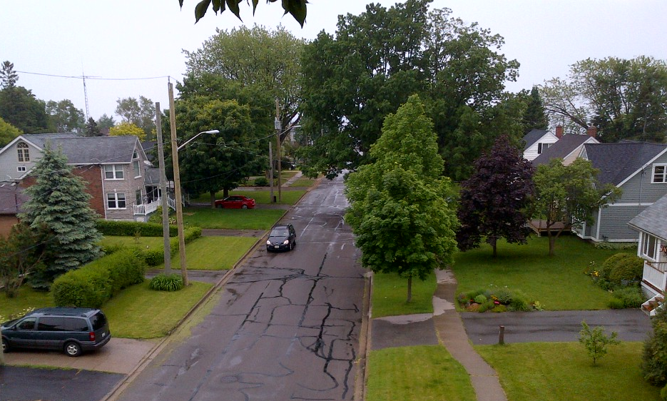
*Based upon the cumulative resource requirements identified in the above workplan, it is recommended that a Forest Technician/Arborist and a Community Stewardship Coordinator be added to the Town staff to support the Town Arborist and Parks Planning in plan implementation.

