 | THE CORPORATION OF THE TOWN OF COBOURG
COMMITTEE OF THE WHOLE
REPORT
TO: | Mayor and Council
FROM:  TITLE: | Desta McAdam  Planner I - Development
DATE OF MEETING: | April 2nd, 2018.
TITLE / SUBJECT: | Application for Approval of a Pre-Servicing Agreement and Subdivision Agreement: Cedar Shore Estates Subdivision  (589 King Street West)  CIMA Canada Inc. / EIE Corporation
REPORT DATE: | March 22nd, 2018 File #: Z-10-15SUB (14T-150001)

1.0 | STRATEGIC PLAN  Objective #4: Managing Sustainable Growth and Development

2.0  3.0 | PUBLIC ENGAGEMENT  Applications for an amendment to the Cobourg Zoning By-law and for approval of a Draft Plan of Subdivision were submitted by RFA Planning Consultant Inc. (Ruth Ferguson Althouse) on behalf of EIE Corporation in November 2015.  The Municipality followed the statutory notice requirements of the Planning Act R.S.O 1990, c.P. 13, as amended, with respect to these applications, including the scheduling of a Public Meeting. A Public Meeting of Council was held on May 16, 2016 regarding these applications. Cobourg Municipal Council considered submissions from area landowners regarding the application. A request regarding the pedestrian pathway alignment for the public waterfront park was taken into account within the Draft Plan of Subdivision Conditions and subsequent detailed subdivision drawing submission. Based on all information available, Cobourg Municipal Council approved the Zoning By-law Amendment and Draft Plan of Subdivision Conditions as proposed in July of 2016. The Draft Plan of Subdivision conditions will expire in July of 2019 if final approval of the subdivision is not granted by Council.  A Notice of Passing/Decision, which included the Conditions of Approval of the Draft Plan of Subdivision, was circulated to Council and other applicable persons/agencies in accordance with the requirements of the Planning Act. The persons on record as making formal submissions to Council during the Zoning By-law Amendment and Draft Plan of Subdivision process will be notified of the pending approval soon after the Committee of the Whole Agenda and this Report are published  RECOMMENDATION  THAT the appropriate By-law be prepared for presentation to Council which authorizes the Mayor and Municipal Clerk to execute a Pre-Servicing Agreement and a Subdivision Agreement with EIE Corporation and Lakefront Utility Services Inc. for the Cedar Shore Estates subdivision development, which will consist of fifteen (15) residential lots, subject to the finalization of details by municipal staff and applicable agencies.

4.0 | ORIGIN  The subject property, known as 589 King Street West, is a 3.2 ha (8.0 ac) parcel of land, presently improved with a residential dwelling and detached coach house building. The property is designated under Part IV of the Ontario Heritage Act.  In July of 2016, an amendment to the Zoning By-law, and a Draft Plan of Subdivision were approved by Council for the development of fifteen single detached dwelling lots over the subject property, including the retention of a substantial-sized lot to encompass the existing heritage home and coach-house building. Further to the approval of the Draft Plan of Subdivision, a number of conditions of draft approval were approved by Council.  The proponent has since submitted detailed plans and supporting documentation to clear the conditions of the Draft Plan of Subdivision approval, and to enter into a Pre-Servicing Agreement and Subdivision Agreement with the Municipality. The Development Review Team and relevant agencies have reviewed the submitted information and plans, and subject to finalization of technical details, the Draft Plan of Subdivision is in a position for final approval.
5.0 | ANALYSIS  The applicant is proposing a residential subdivision development, referred to as “Cedar Shore Estates” consisting of fifteen (15) residential lots, one of which will be maintained by the existing historical residential building and coach house building. The remaining fourteen (14) lots will be improved by single detached residential dwellings. The new lots will front on a new internal road, and a 0.45 ha (1.12 ac) parcel of land along the waterfront will be conveyed to the Town of Cobourg for use as a public park and trail in accordance with the King Street West Village Area special provisions of the Official Plan. A 0.64 ha (1.58 ac) “water lot” extending 45 m – 55 m into Lake Ontario across the entire width of the subject lands is also being conveyed to the Municipality.  The following attachments are included for reference purposes:  Figure 1 – Location Map  Figure 2 – Draft Plan of Subdivision  Figure 3 – Development Plan  Figure 4 – Landscaping and Site Furniture Plan  Figure 5 – Agreement Authorization By-law  Summary of Key Points:  The following are the key points associated with the proposal:  - The approval applies to the Draft Plan of Subdivision, as shown on the Plan prepared by RFA Planning Consultant Inc. (attached hereto as Figure 2) which consists of:  - Fifteen (15) single detached residential lots  - One (1) public park/open space block;  - Two (2) road widening and daylighting blocks;  - One (1) one foot reserve block;  - Two (2) temporary turning bulb blocks;  - One (1) water lot block;  - Streets A and B.  - As part of the development approvals process, the proponent completed a number of technical background studies, recommendation reports and detailed drawings which formed the basis for the ultimate design and implementation of the subdivision, including:  - Planning Report, prepared by RFA Planning Consultant  - Cultural Heritage Impact Assessment, prepared by Golder Associates  - Environmental Impact Assessment, prepared by Golder Associates  - Phase I Environmental Site Assessment, prepared by Golder Associates  - Stages 1-2 & 3 Archeological Assessments, prepared by Golder Associates  - Functional Servicing and Stormwater Report, prepared by CIMA+  - Tree Inventory and Assessment Report, prepared by CIMA+  - Stormwater Management Design Report, prepared by CIMA+  - Architectural Control Guidelines, prepared by Andrew Smith Building Design  - Architectural Guidelines – Homeowner’s Guide  - Geotechnical Investigation Report, prepared by Golder Associates  - Feasibility Noise and Vibration Study, prepared by Golder Associates  - Bat Habitat Investigation, prepared by CIMA+  - Photometric Study/Plan, prepared by CIMA+  The number and scope of detailed technical background materials required for a proposal will vary based on the unique development context applicable to an individual property or project. The information provided for the Cedar Shore Estates development proposal, as referenced above, was determined to be appropriate and comprehensive for this development proposal based on pre-submission assessments by the Planning Department and relevant commenting Departments/Agencies.  - The proposal represents a well-integrated, high quality residential environment. Attractive, thoughtfully considered building designs and dwelling forms will enhance the character of the neighbourhood and reflect the quality image of the community.  - The new subdivision development will be subject to “Architectural Control Guidelines” created by the proponents to appropriately respond to the property’s unique historically-significant built and natural heritage resources. The Guidelines will provide a community design vision for Cedar Shore Estates as well as offer guiding principles which underpin the vision to create a community that achieves planning and urban design excellence. The Guidelines will include specific direction with respect to sustainability, public realm design, architectural design, heritage resources, and a defined implementation process. These Guidelines will be included in the Subdivision Agreement and will be binding on all successive landowners, and the design direction contained in the material shall be interpreted in coordination with existing Town policies and by-laws.  In particular, the Architectural Control Guidelines implement the recommendations of the Cultural Heritage Impact Assessment (CHIA) by including important heritage resource information for the conservation of the existing designated main dwelling and carriage house located on Lot 9, along with a series of ‘proximity’ guidelines for various lots in the subdivision to ensure that new development is designed to be compatible with and sympathetic to the character of this significant heritage resource. Additionally, the document provides future owners with specific requirements for new development, including the following:  - An architectural control process will be required for each of the custom homes within Subdivision Lands. This process is jointly administered by the home designer, the Owner, the Municipality’s Building and Planning Department and, where applicable, the Cobourg Heritage Advisory Committee.  - A Homeowner’s Guide will be provided to purchasers to help support and implement the terms of the Architectural Control Guidelines.  - Lot 9 shall avoid demolition of key landscape features, including the lawn south of the main house.  - Lots/Dwellings 8, 10 and 11 (the lots closest to the heritage property on Lot 9) will be required to substantially conform to Section 7.3.1 Adjacent Heritage Design Guidelines of the Architectural Guidelines.  - Lots/Dwellings 4, 7 and 12 (the lots slightly farther from Lot 9) will be required to substantially conform to Section 7.3.2 Compatible Heritage Design Guidelines of the Architectural Guidelines.  - Lots/Dwellings 1, 2, 3, 5, 6, 13, 14 and 15 (the lots farthest away from Lot 9) will be required to substantially conform to Section 7.3.3 Sympathetic Heritage Design Guidelines of the Architectural Guidelines.  The aforementioned Guidelines are currently being finalized and once complete they will be forwarded to the Cobourg Heritage Advisory Committee for endorsement.  - Sustainable development is promoted and incorporated into the subdivision design. Measures including the use of Low Impact Development (LID) techniques in the backyards of private properties, reduction of impermeable surfaces, and maintaining and supporting an increased tree canopy will enhance the sustainability of the subdivision as a whole. Additionally, new homes will be subject to the requirements of the Ontario Building Code, which currently incorporates a range of energy efficient building standards. The Architectural Control Guidelines encourage other, supplementary measures to increase sustainability objectives including, but not limited to, energy and water efficient fixtures and appliances; rain barrels; zonal heating and cooling; low maintenance building materials with recycled content, employ a waste management policy; and room occupancy sensors.  - Attractive landscaped masonry gateway features denoting the name of the neighbourhood will be constructed on either side of the entrance to the subdivision (Street “A”) to enhance the aesthetic character of the development and for wayfinding purposes. The structures will be located on private property and will be maintained by the individual property owners -- terms and conditions for maintenance will be included in the Subdivision Agreement and applicable Agreements of Purchase and Sale.  - The proponent will preserve a significant number of existing tree resources on the subject property. Specifically the proponent has incorporated protected, natural vegetative buffers along the east and west sides of the development that will be maintained in accordance with specific provisions of the Subdivision Agreement and will be included all Agreements of Purchase and Sale for the affected properties. In addition, specific individual trees of significance have been identified for protection. Other treed areas on the site, comprised mainly of cedars, ash and other less significant vegetation, will be removed due to their health or to accommodate proposed infrastructure and dwellings.  - A 2-stage implementation plan for the tree removals is to be followed: Stage 1 consists of tree removal within the primary infrastructure corridors as part of the initial pre-servicing of the site; and, Stage 2 will be implemented at a later date, closer to new home construction. Where possible, individual trees or clusters may be preserved on a site-specific basis as part of the new home design control process. In accordance with the Environmental Impact Assessment and technical industry guidelines, tree removals are recommended to occur outside of the recognized active bird nesting periods between approx. May and August.  - In response to the presence of bat habitat on the subject property, the proponent conducted a bat habitat investigation (which included a bat habitat suitability assessment), identification of candidate maternity roost trees (ideal trees for bat habitat), and acoustic surveys. The report included a number of recommendations to ensure that a suitable bat habitat could be maintained, which will be incorporated into the Subdivision Agreement and applicable Agreements of Purchase and Sale to ensure both immediate and long term compliance.  - With respect to storm water management, storm sewers will be installed within the corridors of Street “A”, Street “B” and the public waterfront park to convey minor storm flows, with overland drainage to convey the major storm flows. The proposal includes the establishment of a new storm outlet to Lake Ontario, and an “Enhanced” Level of Protection for Stormwater Quality will be achieved utilizing an Oil/Grit Separator (i.e. “Hydroguard” by CIL, or equivalent). This will provide “end of pipe” water quality treatment towards the east limit of Street “B”; at an accessible and maintainable location for the Municipality. The storm sewer outfall will be improved with an asphalt pathway to a look-out deck with decorative safety railings (see Figure 4: landscaping & Site Furnishings Plan).  - The proposal incorporates a new 0.45 ha (1.12 ac) public waterfront parkland block, plus a 0.64 ha (1.58 ac) ‘water lot’, along the entire frontage of Lake Ontario, and includes a 3.0 m wide asphalt public multi-purpose trail that will link Street “B” with Monk’s Cove Park to the east (as shown in Figure 4: Landscaping and Site Furnishing Plan). The trail will be closed to normal vehicular traffic through the use of bollards, but will be available for use as a secondary emergency access and/or parks maintenance road. The new trail will connect to Monk Street at the Maher Street intersection to provide additional separation distance to the single residence on the north side of Monk Street (see Figure 4). The park features will include landscaping, benches and an entry feature installed by the proponent in accordance with the approved plans and terms of the Subdivision Agreement. The western section of the waterfront park will be maintained in a natural state, with a defined nature trail loop intended to protect the natural features in this area.  - A 1.5 m wide concrete sidewalk will be installed on Street “A” and Street “B” between King Street West and the public waterfront trail, and will continue eastward along the south side of King Street West to connect to Maher Street, which will facilitate the establishment of a safe pedestrian loop within and around the neighbourhood. A municipal sidewalk connection on King Street West between Maher Street and Burnham Street was discussed by municipal staff as part of its review, however this work is external to the subdivision lands, is beyond the scope of the proponent to implement and, thus, it would need to be considered by the Municipality as a future municipal capital works project (by ~2020).  - The proponent has agreed to repair the damaged Lake Ontario shoreline along the subdivision frontage to pre-existing conditions (pre-2017 erosion) in accordance with a shoreline restoration and management plan to the satisfaction of the Municipality, prior to the Town’s assumption of the parkland, and will form part of the subdivision’s performance security and Subdivision Agreement.  - The lot lines of the properties abutting the waterfront park are to incorporate decorative metal fencing without gates to provide a consistent and attractive edge to the park, the terms and conditions of which will be included in the Subdivision Agreement and all applicable Agreements of Purchase and Sale.  - Archaeological resources which were identified on parts of the subdivision lands during the initial Archaeological Assessments have been addressed and cleared in accordance with Provincial Ministry guidelines.  - Street “B” has been designed to extend westward in the future, should development be contemplated, however in the interim a temporary cul-de-sac will be constructed complete with a landscaped buffer at its western terminus.  - The street names for the subdivision have yet to be determined. Discussions between the proponent and Planning Department staff are underway with a number of options proposed that reflect the heritage, character and context of the property for review by the Cobourg Heritage Advisory Committee and approval by Council (to be considered in a separate Report and prior to the registration of the Plan of Subdivision).  - A 3.4 m wide road allowance dedication along the frontage abutting King Street West will be conveyed to the Municipality as a condition of the Subdivision Agreement.  - Noise attenuation measures will be incorporated into the development and Subdivision Agreement and Agreements of Purchase and Sale pursuant to the recommendations of the Feasibility Noise & Vibration Assessment and railway requirements, including noise warning clauses, architectural buffering and a noise fence. The noise fence is limited to the rear yard areas abutting King Street West, complete with landscaping designed to buffer the public realm.  - Once the Plan of Subdivision and Subdivision Agreement are registered on title, the Municipality will be required to amend/replace the existing heritage designation by-law that applies to the entire subdivision lands to only apply to Lot 9 (the new lot which will encompass the existing historic dwelling and coach-house building). The proponent will be required to consent to this procedure as a condition of the Subdivision Agreement.
6.0 | FINANCIAL IMPLICATIONS/BUDGET IMPACT  There are no anticipated negative financial implications imposed on the Municipality as a result of granting final approval of the Plan of Subdivision application. The developer will be responsible for all costs associated with the installation of infrastructure to service the subdivision, estimated to be approx. $1,500,000.00. The Owner has submitted the requisite Plans of Subdivision Clearance application fee to the Municipality in the amount of $6,100.00. A municipal tree levy of $13,345.00 will be collected as a condition of the proposed development.  Because 14.1% of the subject property is being conveyed to the Municipality for park purposes, in excess of the 5% maximum permitted under the Planning Act and in accordance with the King Street West Village Area policies of the Official Plan, a cash in lieu of parkland payment is not being provided. There will be ongoing maintenance required by the Municipality once the shoreline is restored, the park improvements have been completed and the park is assumed by the Municipality.

7.0 | CONCLUSION  It is the opinion of the Planning Department that the application submitted by CIMA Canada Inc. on behalf of EIE Corporation to clear Conditions of Draft Subdivision Approval for the area known as 589 King Street West (Cedar Shore Estates) satisfies the conditions of approval, subject to the finalization of details by planning staff and applicable agencies.  Yours very truly,  THE CORPORATION OF THE TOWN OF COBOURG  Desta McAdam  Planner I - Development

FIGURE 1: LOCATION MAP
N

Subject Lands

FIGURE 2: DRAFT PLAN OF SUBDIVISION

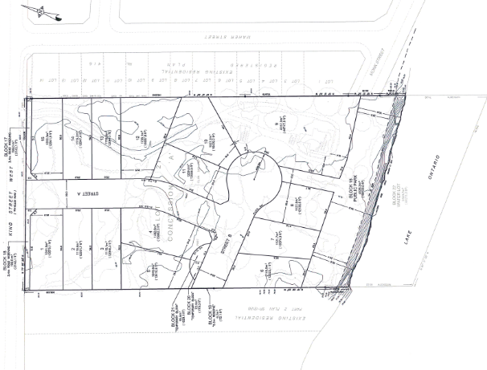
FIGURE 3: DEVELOPMENT PLAN
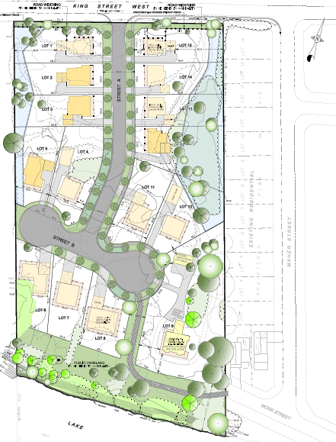

Trail location and length has since shifted to respond to public comments. The revised trail is shown in Figure 4 of this report.

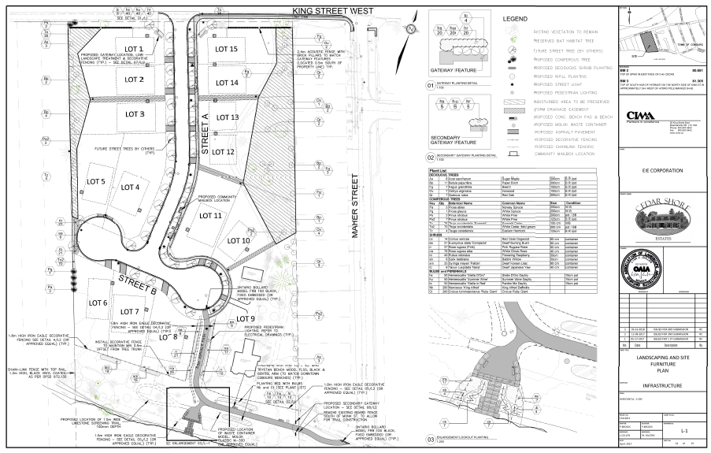
FIGURE 4: LANDSCAPING AND SITE FURNISHING PLAN

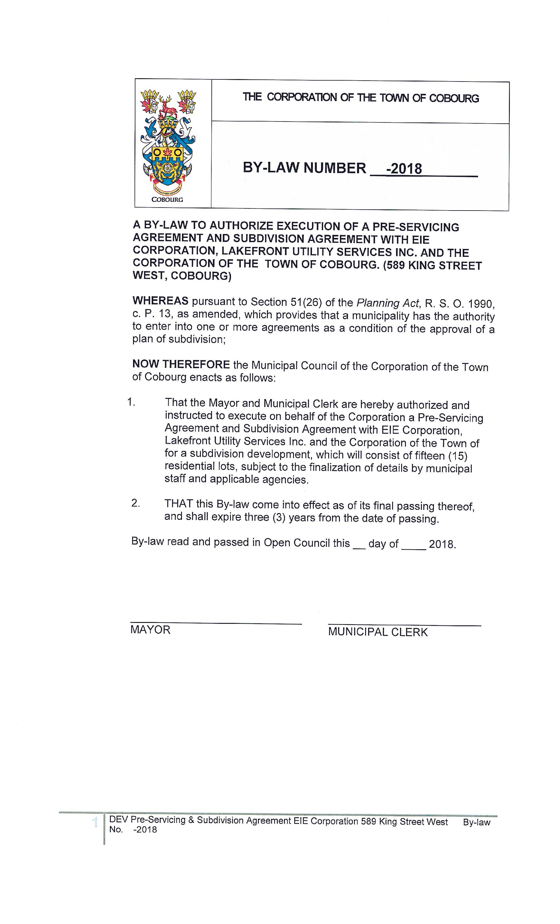FIGURE 5: AGREEMENT AUTHORZATION BY-LAW

