 | THE CORPORATION OF THE TOWN OF COBOURG
 | STAFF REPORT
TO: | Mayor and Council
FROM:  TITLE: | Desta McAdam  Senior Planner – Development
DATE OF MEETING: | March2019
TITLE / SUBJECT: | Plan of Subdivision Application: 425 King Street East  Ruth Ferguson Aulthouse (RFA Planning Consultant) / Mason Homes
REPORT DATE: | February 21st, 2019. File #: Z-03-18SUB 14T-180001

1.0 | STRATEGIC PLAN  N/A

2.0  3.0 | PUBLIC ENGAGEMENT  Section 51 (20) of the Planning Act, RSO 1990, c.P.13, as amended prescribes statutory notice requirements for a complete plan of subdivision application, and for the scheduling of a public meeting or open house.  Notice of a complete plan of subdivision application and notice of a public meeting or open house can be provided together. The Municipality is required to give notice by either:  a) publication in a newspaper that is of sufficient circulation in the area which the application applies; or  b) personal or ordinary service mail to every land owner within 120 metres of the subject land, and by posting a notice, clearly visible from a public highway or other place the public has access on the subject land, or a location chosen by the municipality.  The Municipality’s notification procedures for complete applications and public meetings comply with the notice requirements prescribed by the Planning Act.  RECOMMENDATION  The following actions are recommended:  a) That the application be received by Council and referred to the Planning Department for a report; and,  b) That the notice requirements of the Planning Act, RSO 1990, as amended, be implemented, including the scheduling of a Public Meeting.

4.0 | ORIGIN  The Planning Department has received a complete application for approval of a plan of subdivision from RFA Planning Consultant on behalf of Mason Homes (authorized by the landowner, Thomas and Alice Behan) which proposes to create five (5) townhouse blocks, to facilitate the creation of a total of twenty-seven (27) freehold townhouse dwelling lots.

5.0 | BACKGROUND  The property known as 425 King Street East is a 1.58 ha (3.90 ac) parcel, with 88.61 m (290.71 ft) frontage along King Street East. The site has been vacant for approximately twenty years, and was previously improved by a motel.  The Subject Lands are designated as “Mixed Use Area” in the Town of Cobourg Official Plan (2017), and zoned “Multiple Residential 4 Exception 4 [R4-4(H)] Zone” in the Comprehensive Zoning By-law No. 85-2003.  The application proposes twenty-seven (27) new freehold townhouse lots within five (5) residential blocks. The proposed townhouse lots will have municipal road access via an internal municipal road, being an extension of Orchard Avenue. The proposed extension will continue Orchard Avenue east, into the subject property, then north, to King Street East. The proposed lot frontages range from 8.9 m for interior lots, and between 11.4 m – 18.0 m for exterior lots. Presently, the R4-4 (H) Zone permits the proposed land use, and therefore, a zoning by-law amendment is not required.

6.0 | ANALYSIS  This memo is for application receipt notification purposes only and there is subsequently no staff analysis at this time. The application package, including the draft plan of subdivision and supporting information, are currently being reviewed by the Development Review Team and applicable agencies/committees before being brought back to Council for consideration.  Formal public notifications of the applications and future public meeting will be provided in accordance with Planning Act regulations. Pursuant to the provisions of the Planning Act, if the Municipality fails to approve the plan of subdivision application within 180 days after its submission, the Owner may appeal the application to the Ontario Municipal Board/Local Planning Appeal Tribunal.

7.0 | FINANCIAL IMPLICATIONS/BUDGET IMPACT  There are no anticipated negative financial implications imposed on the Municipality as a result of a Zoning By-Law Amendment. The Owner has submitted the requisite $8,255.00 application fee and deposit.

8.0 | CONCLUSION  The application package and supporting information, are currently being reviewed by the Development Review Team and applicable agencies/committees before being brought back to Council for consideration.  Please contact the Planning Department if you have any questions or concerns.

Respectfully submitted,

Desta McAdam
Senior Planner – Development

SCHEDULE ‘A’
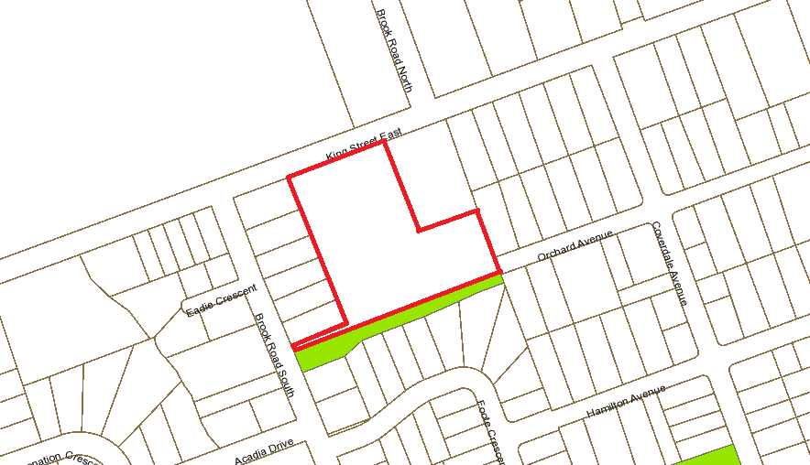
N
Subject Lands

