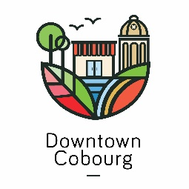
November 12, 2017
News Release
For Immediate Release
Downtown Holiday Window Decorating Contest
COBOURG, ON – Businesses are joining in on the holiday fun and making the downtown a sight to see with the annual Holiday Window Decorating Contest. The Cobourg DBIA invites locals and visits to come downtown to enjoy the festive window displays.
Businesses are aiming to have their windows complete by November 18, just in time for the Santa Claus Parade in Downtown Cobourg. The local businesses are competing for top honors as having the Best Holiday Window Decoration. The contest runs during the Countdown to Christmas event weekend, which begins Friday, November 24 to Sunday, November 26.
During the contest, our secret panel of judges will walk the windows to determine which business has best captured the holiday spirit. The window decorating contest also has a People’s Choice Award. The community is invited to tour downtown Cobourg and visit participating businesses. After viewing the wonderful storefronts, the public can cast their votes online on Facebook or in person at the Cobourg DBIA tent over the Countdown to Christmas event weekend. We will post an album of all participating business windows on Facebook, and fans will be able to vote by “liking” their favourite window. Voting for the People’s Choice Award will be open from Friday, November 24 to Sunday, November 26. The winners of the window decorating contest will be announced November 30th. The window decorations will be on display through Christmas Day.
“The holiday window decorating contest is a fun way to celebrate the holiday season, create a festive and beautiful downtown, attract visitors, and showcase the local businesses,” says Paige Montgomery, Events and Communications Coordinator.
This Christmas season visit downtown Cobourg to see festive window displays, shop for that perfect holiday gift, and celebrate with friends and family at our wonderful restaurants.
-30-
For more information, please contact:
Paige Montgomery, Events & Communications Coordinator
Cobourg Downtown Business Improvement Area (DBIA)
dbia@downtowncobourg.ca | (905) 377-8024

