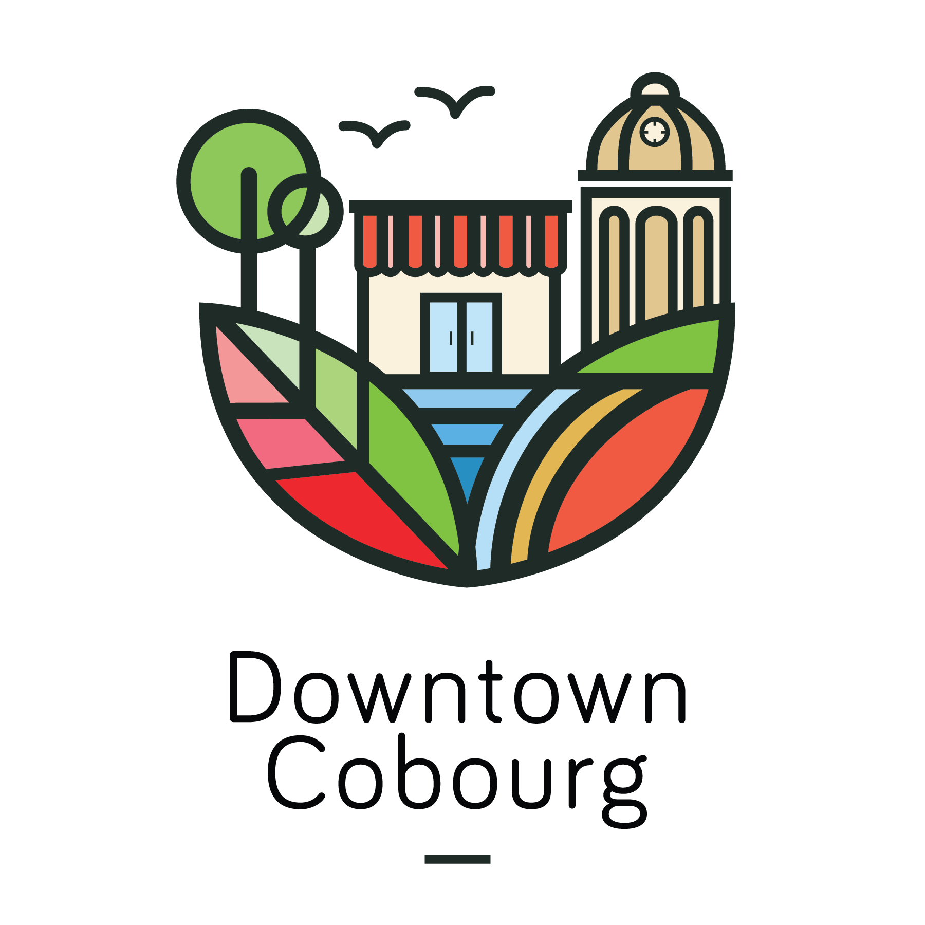
July 26th, 2017
Press Release
For Immediate Release

49th ANNUAL SIDEWALK SALE

COBOURG, ON – Downtown Cobourg presents the 49th annual Sidewalk Sale! From Thursday, August 3rd to Sunday, August 6th, join the Cobourg DBIA as we host blocks of extended storefronts and street vendors on King Street West.

Each day brings new activities and entertainment to Downtown Cobourg for all ages to enjoy! The event will be filled with live music, family fun, and summer sales. From inflatables to sandcastles, Latin music to the best of Canadian Rock, there’s something that everyone will love.

“The Special Events Committee is proud to present the 49th annual Sidewalk Sale in Downtown Cobourg,” says Rino Ferreri, Chair of Special Events. “The Sidewalk Sale promises to be once again a phenomenal shopping event, drawing thousands from all over Ontario to Cobourg.”

Come downtown to the Sidewalk Sale – your favourite local merchants will be bringing their best #DowntownDeals for the 4 day shopping experience of the summer!

Event Details:
  - Each day offers different hours and activities
    - Thursday, August 3rd: 8:00AM to 7:00PM
      - Live music: The Imbayakunas, and The Farrucas Duo
      - Shelter Valley Folk Festival Songwriter’s Showcase, starting at 6:00pm
      - Sandcastle on King St.
    - Friday, August 4th: 8:00AM to 9:00PM
      - Inflatables: The Brave Knight, and a 40ft Obstacle Course
    - Saturday, August 5th: 8:00AM to 6:00PM
      - Kids activities: Face painting and free balloon animals
      - Flash mob by 3M Dance Works
    - Sunday, August 6th: 11:00AM to 4:00PM
      - Live music: Trilogy, a “Salute to the Best of Canadian Rock”
- Food trucks on Second St.
  - Funnel Cake Dreams, Smoke’s Poutinerie, Justice Burgers, Harbourlight Delights, Squeezy’s and more

For a complete list of the 2017 Calendar of Events in Downtown Cobourg, visit www.downtowncobourg.ca

For more information, please contact:
Paige Montgomery, Event & Communications Coordinator
Cobourg Downtown Business Improvement Area
dbia@downtowncobourg.ca | (905) 377-8024

