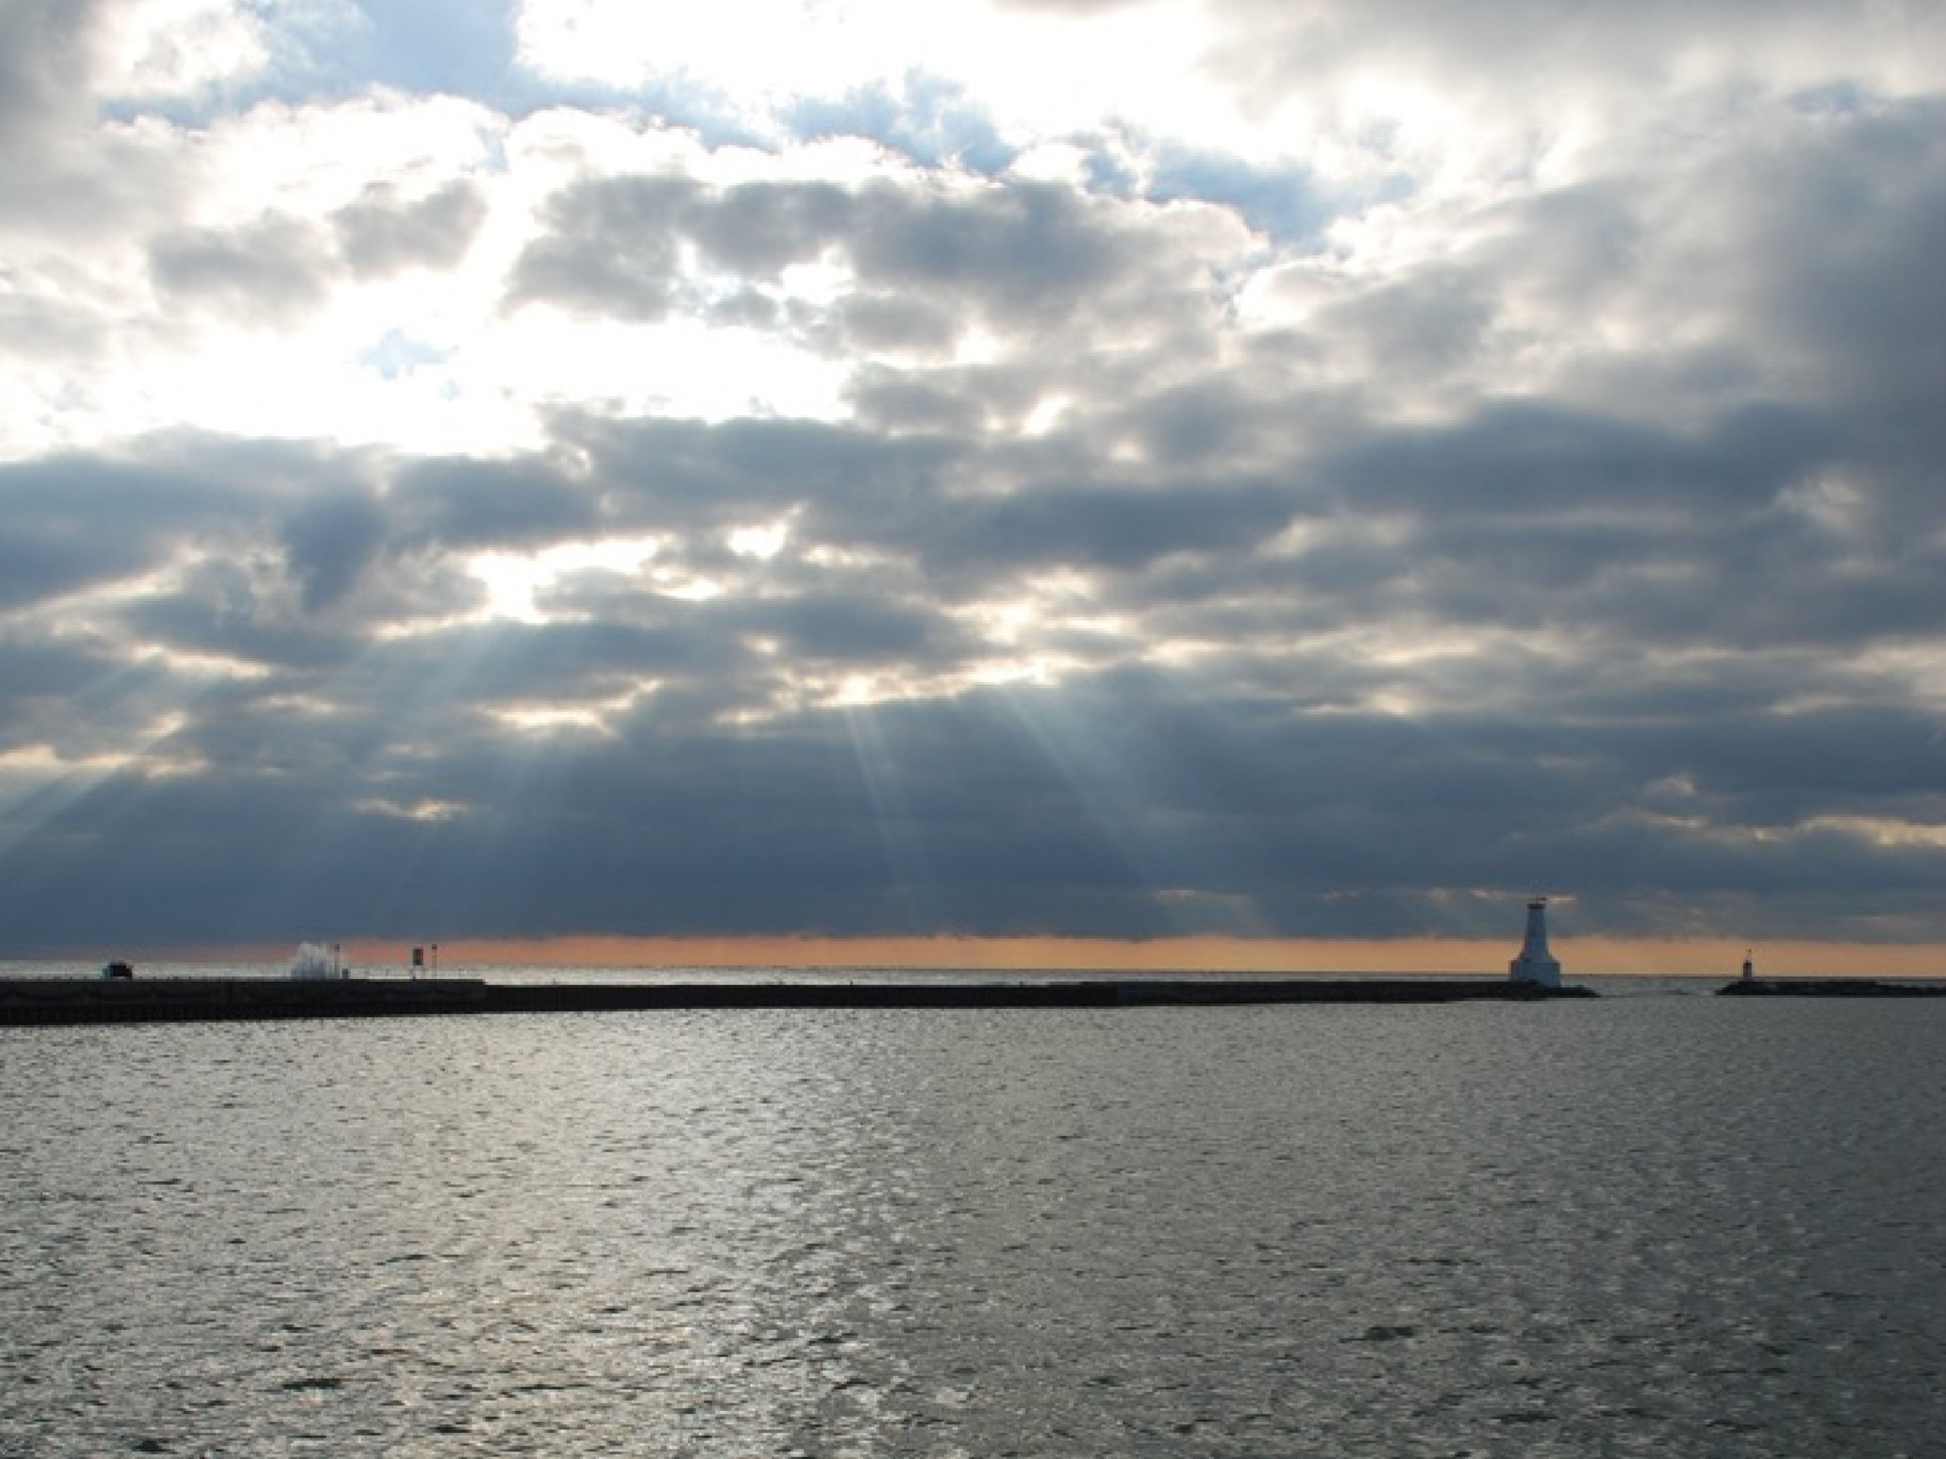
Open House #4: Waterfront User Needs Assessment & Detailed Design
Waterfront User Needs Assessment & Detailed Design
Projects & Priorities
Open House #4
Thursday October 26, 2017
1
to 8 PM
Town of Cobourg

Agenda
- Meeting Focus
- Process/Schedule
- Consultation Overview
- 80 Design Initiatives
- Dot Exercise
- Priority Matrix
- 29 Projects
- Next Steps
Open House #4: Waterfront User Needs Assessment & Detailed Design

Meeting Focus
- Present results from June open house #3 dot exercise
- Provide overview of work completed since June open house #3
- Receive input on:
  - thirteen (13) scoring matrix criteria and percentage weights
  - eighty (80) initiative priorities
  - twenty-nine (29) project groupings
  - Twenty-five (25) year implementation sequence
Council Update: Waterfront User Needs Assessment & Detailed Design

Meeting Format
- Open House from 1 to 8 PM
- 15 minute overview presentation (2 PM, 5 PM and 7 PM)
- Review information boards of DRAFT recommendations
- Ask questions of team members
- Provide written comments
Council Update: Waterfront User Needs Assessment & Detailed Design

Process/Schedule
Stage 1: Research
+
Policy Review
Stage 2:
Assessment + Draft
Project Plan
Stage 3: Final
Plan
February to May
May to June
July to December
‣
Steering Committee
meetings
‣
Municipal
Representative
Meetings
‣
Public Open House/
Workshop #1
‣
Stakeholder Meetings
‣
Public Open House/
Workshop #2
‣
Surveys
‣
Steering Committee
meetings
‣
Community Design
Charrette
‣
Surveys
‣
Workshop #3
‣
Steering Committee
meetings
‣
Public Open House/
Workshop #4
‣
Final Plan (post online
for commenting)
‣
Presentation to
Council
DRAFT
BACKGROUND
we are here
REFINE

Consultation Activities
- Meetings with Municipal Representatives March 21 (24)
- Open House/Workshop (#1) April 4 (62)
- Stakeholder Meetings April 10, 11 + May 3 (27 groups)
- Open House/Workshop (#2) May 10 (61)
- Community Design Charrette May 31 (100)
- Open House/Workshop (#3) June 27 (91)
- Council Update August 21
- Public Open House/Workshop (#4) Today

Feedback Opportunities
- Comment forms at open house/workshop meetings
- Design Charrette
- Resident Survey
- Business Survey
- User Groups and Service Clubs Survey
- Dot Exercise (Workshop #3)

80 Design Initiatives Design Initiative Groupings
‣ Organized into ten (10) areas or topics
- West Beach and Headland
- Harbour 3. Marina
- East Pier
- Victoria Beach
- Campground
- Victoria Park
- Parking and Traffic Management
- Waterfront Linkages and Connections
- Other Waterfront Parks and Open Spaces

Eighty (80) Design Initiatives
- The 80 design initiatives are illustrated on panels organized by topic /area
- Each initiative is numbered to correspond to each topic/area
- Designs and their associated recommendations are presented as DRAFT/preliminary
- All feedback received from public, staff and Council following June meeting was considered in further refinement of recommendations

Dot Exercise

- Each participant was provided with 12 dots
- Dots were to be placed on projects of the highest priority
- Only one dot per project
- Members of the design team were available to
answer questions and discuss the overall plan and the various proposed initiatives
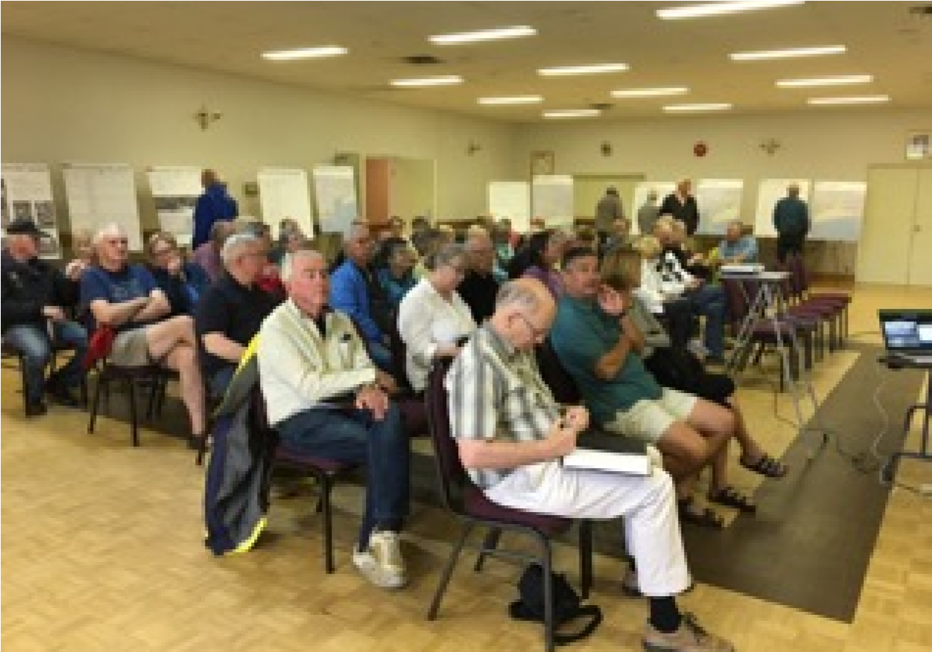
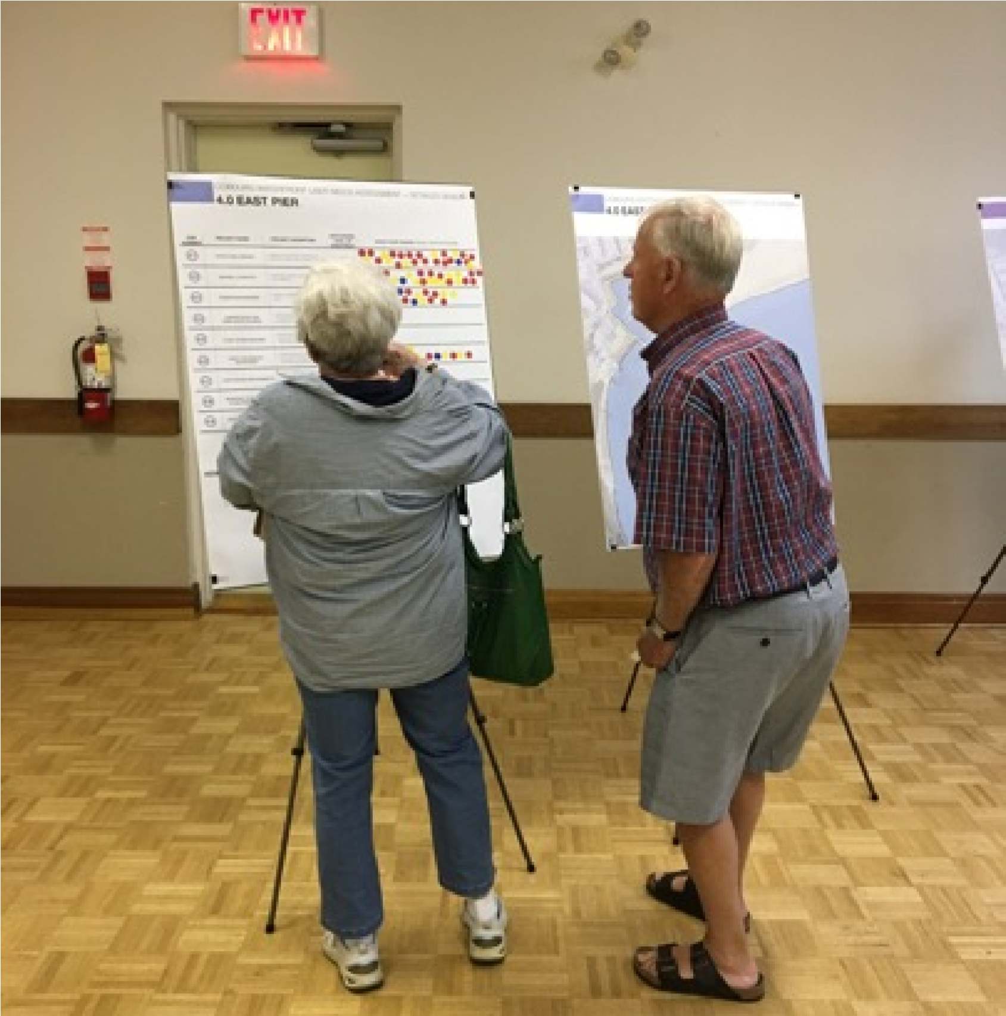
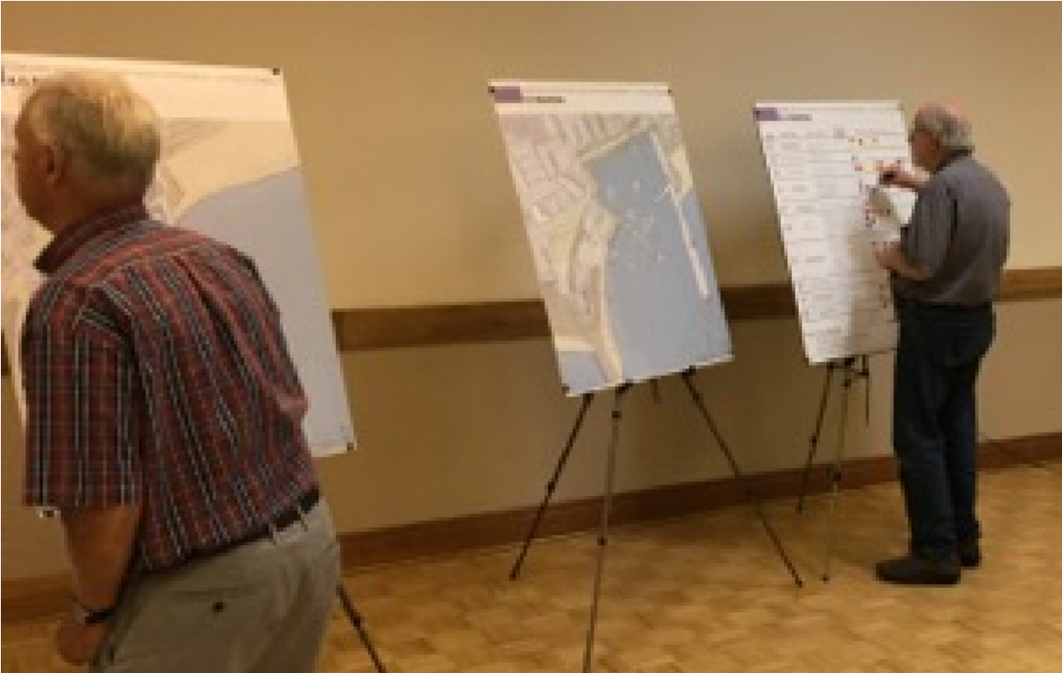
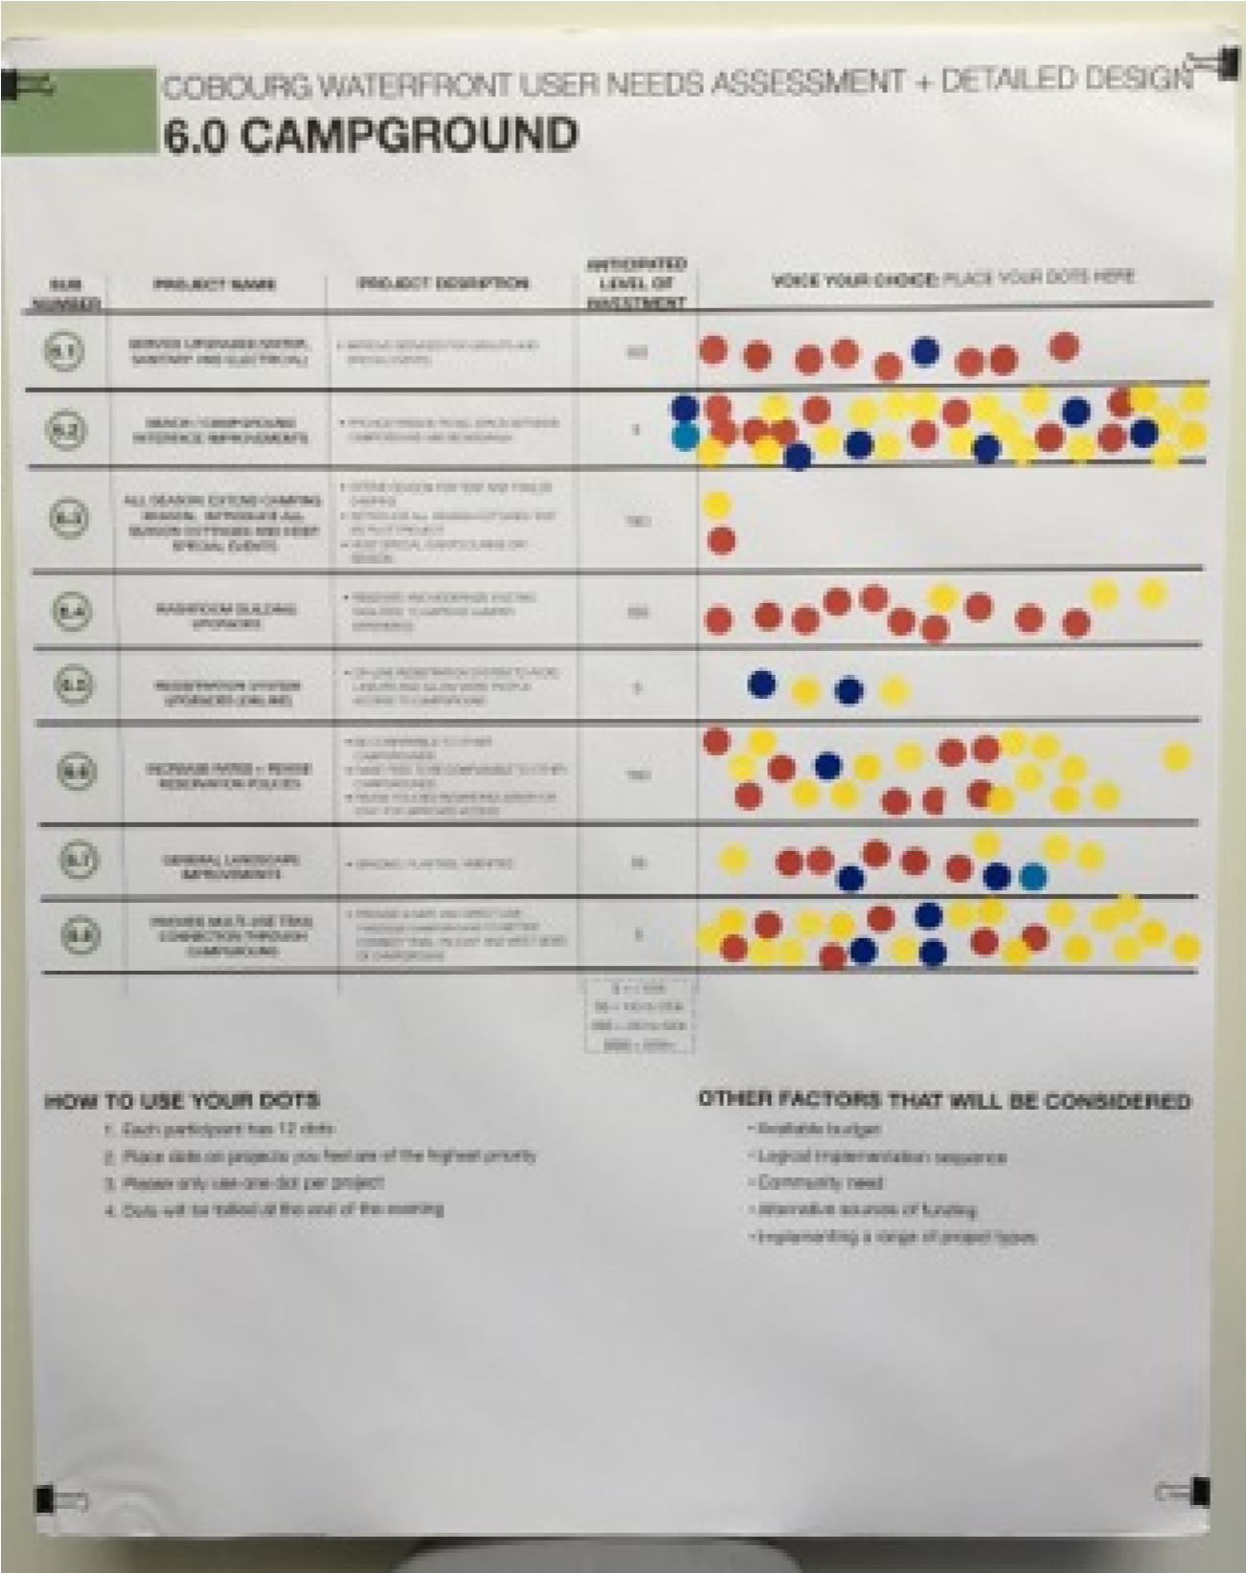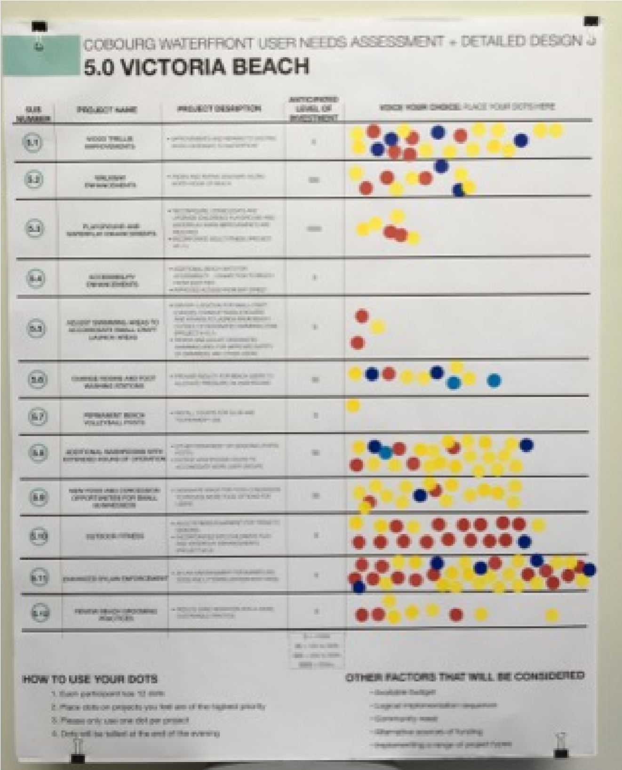
Results
- Total of 1045 dots were applied to 80 initiatives
- Top initiative: beach and headland naturalization received 42 dots
- Top ten (10) initiatives received 36% of dots
- Top twenty (20) initiatives received 60% of dots Results ranked 1 to 10
 | Prj. # | Project Name | # of  Dots | Score / 10
1 | 1.2 | Beach and headland naturalization | 42 | 10.0
2 | 7.6 | General enhancements to Victoria Park (trees, sod, seating) | 40 | 9.5
3 | 4.1 | Structural repairs (East Pier) | 39 | 9.3
4 | 4.2 | Seating/lookouts (East Pier) | 39 | 9.3
5 | 9.3 | Formalize pedestrian link between east and west core waterfront | 37 | 8.8
6 | 5.11 | Enhanced bylaw enforcement (Victoria Beach) | 36 | 8.6
7 | 6.2 | Beach/campground interface improvements | 36 | 8.6
8 | 8.1 | Parking permits for residents | 36 | 8.6
9 | 1.6 | Viewing platform at breakwall | 34 | 8.1
10 | 4.3 | Pedestrian walkway (on East Pier) | 32 | 7.6
 | Prj. # | Project Name | # of  Dots | Score / 10
11 | 1.1 | Pedestrian walkway (West Beach and Headland) | 31 | 7.4
12 | 3.3 | Off-site boat storage | 27 | 6.4
13 | 3.7 | Multi-use community waterfront building | 27 | 6.4
14 | 4.8 | Seasonal closure of pier to motorized vehicles | 27 | 6.4
15 | 2.1 | Expand dredging operations | 26 | 6.2
16 | 6.8 | Provide multi-use trail connection through campground | 26 | 6.2
17 | 5.8 | Additional washrooms with extended hours of operation | 25 | 6.0
18 | 6.6 | Increase rates and revise policies (campground) | 23 | 5.5
19 | 5.1 | Wood trellis improvements (Victoria Beach) | 21 | 5.0
20 | 5.10 | Outdoor fitness (Victoria Beach) | 19 | 4.5
Results ranked 11 to 20
Results ranked 21 to 30
 | Prj. # | Project Name | # of  Dots | Score / 10
21 | 10.11 | Lucas Point Park | 19 | 4.5
22 | 2.2 | Floating dock and non-vehicle launch ramp for small watercraft (Inner Harbour) | 18 | 4.3
23 | 5.9 | New food and concession opportunities for small businesses (Victoria Beach) | 17 | 4.0
24 | 9.2 | Establish strategy for future connections across private parcels | 16 | 3.8
25 | 7.4 | Additional shade structures (Victoria Park) | 15 | 3.6
26 | 8.4 | Event shuttle service | 15 | 3.6
27 | 9.1 | Waterfront link between Cobourg and Port Hope (Waterfront Trail) | 15 | 3.6
28 | 7.5 | Public washrooms (Victoria Park) | 14 | 3.3
29 | 3.10 | Add boat slips to west side of central pier | 13 | 3.1
30 | 4.6 | Food concession / restaurant (East Pier) | 13 | 3.1
Results ranked 31 to 40
 | Prj. # | Project Name | # of  Dots | Score / 10
31 | 6.4 | Washroom building upgrades (campground) | 13 | 3.1
32 | 3.1 | Reduce percentage of transient boat slips | 12 | 2.9
33 | 6.7 | General landscape Improvements (campground) | 12 | 2.9
34 | 7.3 | Pathway improvements/connections (Victoria Park) | 12 | 2.9
35 | 3.6 | Travel-lift | 10 | 2.4
36 | 5.2 | Walkway enhancements (Victoria Beach) | 10 | 2.4
37 | 5.6 | Change rooms and foot washing stations | 10 | 2.4
38 | 8.6 | Improved signage and enforcement | 10 | 2.4
39 | 3.4 | Boat storage reconfiguration | 9 | 2.1
40 | 5.12 | Review beach grooming practices | 9 | 2.1
Results ranked 41 to 50
 | Prj. # | Project Name | # of  Dots | Score / 10
41 | 6.1 | Campground servicing upgrades (water, sanitary and electrical) | 9 | 2.1
42 | 7.2 | Bandshell improvements | 9 | 2.1
43 | 8.2 | Improvements to pickup and drop-off circle at foot of Charles Street | 9 | 2.1
44 | 10.3 | Monks Cove Park | 9 | 2.1
45 | 10.7 | D'arcy Street Lookout | 9 | 2.1
46 | 1.4 | Boardwalk fingers (West Beach and Headland) | 8 | 1.9
47 | 1.5 | Ecology garden pathways | 8 | 1.9
48 | 8.5 | Parking structure downtown | 8 | 1.9
49 | 3.8 | Security enhancements (Marina) | 7 | 1.7
50 | 8.8 | Metered parking on streets adjacent to waterfront during peak season | 7 | 1.7
 | Prj. # | Project Name | # of  Dots | Score / 10
51 | 3.9 | Public small craft boat storage compound | 6 | 1.4
52 | 5.3 | Playground and waterplay enhancements (Victoria Beach) | 6 | 1.4
53 | 10.4 | Peace Park | 5 | 1.2
54 | 10.5 | Cedermere Ave Lookout | 5 | 1.2
55 | 10.6 | Donegan Park | 5 | 1.2
56 | 3.2 | Central pier improvements | 4 | 1.0
57 | 6.5 | Registration system upgrades – online (campground) | 4 | 1.0
58 | 8.7 | Esplanade parking and traffic flow improvements | 4 | 1.0
59 | 10.9 | Lookout Point Park | 4 | 1.0
60 | 4.7 | Light house improvements | 3 | 0.7
Results ranked 51 to 60
Results ranked 61 to 70
 | Prj. # | Project Name | # of  Dots | Score / 10
61 | 5.5 | Adjust swimming areas to accommodate small craft launch areas | 3 | 0.7
62 | 7.1 | Electrical and water service upgrades | 3 | 0.7
63 | 8.3 | Tiered parking strategy | 3 | 0.7
64 | 8.11 | Seasonal use of boat storage compound as overflow parking | 3 | 0.7
65 | 10.8 | Brook Road Lookout | 3 | 0.7
66 | 1.3 | Signage, wayfinding and interpretation (West Beach and Headland) | 2 | 0.5
67 | 4.4 | Charter boat and deep water docking | 2 | 0.5
68 | 4.5 | Coast Guard building | 2 | 0.5
69 | 6.3 | All season: extend camping season, introduce all season cottages and host special events | 2 | 0.5
70 | 8.9 | Formalize overflow parking at Donegan Park | 2 | 0.5
Results ranked 71 to 80
 | Prj. # | Project Name | # of  Dots | Score / 10
71 | 10.10 | Fitzhugh Shores Parkette | 2 | 0.5
72 | 3.5 | Loading/unloading zone for marina users | 1 | 0.2
73 | 5.7 | Permanent beach volleyball posts | 1 | 0.2
74 | 8.10 | Reconfiguration of Hibernia Street/Marina parking lot | 1 | 0.2
75 | 9.4 | Signage strategy directing pedestrians between waterfront and downtown | 1 | 0.2
76 | 2.3 | Formalize paddling course (small bouys and signage) for shared use of harbour | 0 | 0.0
77 | 4.9 | Electrical upgrades and pedestrian lighting | 0 | 0.0
78 | 5.4 | Accessibility enhancements | 0 | 0.0
79 | 10.1 | Green Street small craft launch | 0 | 0.0
80 | 10.2 | Tracey Parkette | 0 | 0.0

Priority Matrix
- Other factors need to be considered in prioritizing initiatives for implementation
- Priority matrix was developed as a tool to further score each project to determine priority
- Criteria selected focus on improving the waterfront for residents, addressing infrastructure needs, and revenue generation
Scoring criteria and weighting

- Results from dot exercise
(15%)
- Beautification, arts & culture
(5%)
- Tourism management (7%)
- Health, wellness and fitness
(5%)
- Naturalization of environment
(7%)
- Estimated costs (10%)
- Safety and security (7%)
- Improving access (10%)
- Anticipated level of use (4%)
10.Multi-season benefit (5%)
11.Business operations & customer service (10%)
12.Revenue generation (10%)
13.Ease of implementation (5%)

Scoring criteria
- Each of the 80 projects was tested against each of the 13 criteria
- Scoring applied based on how well it addresses the criteria
Significant = 10
Moderate = 5
Minimal = 0
- Example:
- Total score awarded out of 100
Preliminary Results | Score/100 | Priority  Ranking | Dot  Exercise  Ranking | Change in  Ranking
1
2
3
4
5
6
7
8
9
10
11
12
13
14
15
16
17
18
18
20
21
22
23
24
25
26
- 1.1 Pedestrian walkway along headland 5811 10
- 3.6 Travel-lift 5835 33
- 3.7 Multi-use community waterfront building 5612 9
- 4.1 Structural repairs to East Pier 553 -1
- 1.6 Viewing platform at breakwall 529 4
- 5.11 Enhanced bylaw enforcement at Victoria Beach 486 0
- 4.3 Pedestrian walkway on East Pier 4810 3
- 8.1 Parking permits for residents 466 -2 9 4.2 Seating/lookouts at East Pier 443 -6
- 8.5 Parking structure downtown 4446 36
- 6.6 Increase campground rates and revise policies 4418 7
- 6.2 Beach/campground interface improvements 416 -6
- 1.5 Ecology garden pathways 4146 33
- 7.3 Pathway improvements/connections at Victoria Park 4132 18
- 10.11 Lucas Point Park 4120 5
- 5.9 New food and concession opportunities for small businesses at Victoria Beach 4123 7
- 2.2 Floating dock and non-vehicle launch ramp for small watercraft 4022 5
- 7.2 Bandshell improvements 4039 21
- 4.4 Charter boat and deep water docking 4066 48
- 4.6 Food concession / restaurant on East Pier 4029 9
- 8.8 Metered parking on streets adjacent to waterfront during peak season 3949 28
- 3.9 Public small craft boat storage compound 3951 29
- 3.3 Off-site boat storage 3912 -11
- 7.4 Additional shade structures in Victoria Park 3825 1
- 3.5 Loading/unloading zone for marina users 3872 47
- 10.3 Monks Cove Park 3739 13

Preliminary Results
26
26
29
30
31
32
33
34
35
36
37
38
39
40
41
42
43
44
45
46
47
48
49
50
51
51
53
- 10.7 D'arcy Street Lookout 3739 13
- 3.4 Boat storage reconfiguration 3739 13
- 6.5 Registration system upgrades (online) for campground 3756 27
- 6.8 Provide multi-use trail connection through campground 3715 -15
- 5.2 Walkway enhancements at Victoria Beach 3735 4
- 1.2 West beach and headland naturalization 371 -31
- 1.4 Boardwalk fingers at West Beach 3646 13
- 10.5 Cedermere Ave Lookout 3653 19
- 10.1 Green Street small craft launch 3676 41
- 10.9 Lookout Point Park 3556 20
- 6.3 All season: extend camping season, introduce all season cottages and host special ev 3566 29
- 4.8 Seasonal closure of pier to motorized vehicles 3512 -26
- 10.8 Brook Road Lookout 3560 21
- 10.10 Fitzhugh Shores Parkette 3566 26
- 1.3 Signage, wayfinding and interpretation along West Beach and headland 3466 25
- 3.10 Add boat slips to west side of central pier 3429 -13
- 8.6 Improved parking and traffic signage and enforcement 3435 -8
- 10.2 Tracey Parkette 3476 32
- 10.4 Peace Park 3453 8
- 9.3 Formalize pedestrian link between east and west core waterfront 335 -41
- 7.6 General Park enhancements (trees, sod, seating) to Victoria Park 332 -45
- 3.8 Security enhancements 3249 1
- 3.2 Central pier improvements 3256 7
- 5.5 Adjust swimming areas to accommodate small craft launch areas 3260 10
- 6.1 Service upgrades at campground (water, sanitary and electrical) 3139 -12
- 8.9 Formalize overflow parking at Donegan Park 3166 15
- 10.6 Donegan Park 3153 0

Preliminary Results
54
55
56
57
58
59
60
61
62
63
64
65
66
66
68
69
70
71
72
73
74
75
76
77
78
79
80
- 5.4 Accessibility enhancements to Victoria Beach 3076 22
- 5.3 Playground and waterplay enhancements 3051 -4
- 8.3 Tiered parking strategy 2960 4
- 8.7 Esplanade parking and traffic flow improvements 2956 -1
- 7.1 Electrical and water service upgrades to Victoria Park 2960 2
- 8.4 Event shuttle service 2825 -34
- 9.2 Establish strategy for future connections across private parcels 2824 -36
- 9.1 Waterfront link between Cobourg and Port Hope (Waterfront Trail) 2725 -36
- 2.1 Expand dredging operations 2715 -47
- 8.2 Improvements to pickup and drop-off circle at foot of Charles Street 2739 -24
- 5.10 Outdoor fitness at Victoria Beach 2620 -44
- 5.7 Permanent beach volleyball posts 2672 7
- 2.3 Formalize paddling course (small bouys and signage) for shared use of harbour 2676 10
- 7.5 Public washrooms in Victoria Park 2628 -38
- 6.7 General landscape Improvements at campground 2532 -36
- 5.8 Additional washrooms with extended hours of operation at Victoria Beach 2417 -52
- 9.4 Signage strategy directing pedestrians between waterfront and downtown 2372 2
- 5.1 Wood trellis improvements 2319 -52
- 6.4 Washroom building upgrades at campground 2229 -43
- 5.6 Change rooms and foot washing stations at Victoria Beach 2135 -38
- 4.7 Light house improvements 2060 -14
- 5.12 Review beach grooming practices 1939 -36
- 8.11 Seasonal use of boat storage compound as overflow parking 1960 -16
- 4.9 Electrical upgrades and pedestrian lighting along East Pier 1976 -1
- 4.5 Coast Guard building 1366 -12
- 8.10 Reconfiguration of Hibernia Street/Marina parking lot 1272 -7
- 3.1 Reduce percentage of transient boat slips 1032 -48

29 Projects

Projects
- Initiatives are organized into projects for implementation (1-5 initiatives per project)
- Projects are grouped based on compatibility, logical
implementation sequence and budget considerations
- Twenty-nine projects proposed
- Preliminary costing provided
- Costs divided between design and construction
- Projects forecasted over a 25 year schedule

Next Steps
- Incorporate feedback from today’s Open House
Workshop #4
- Meet with Steering Committee
- Refine recommendations and report based on feedback received
- Make draft report available for community commenting
- Incorporate feedback and present to Council

Feedback
Please provide comments on any of the following using the provided comment sheets:
- thirteen (13) scoring matrix criteria and percentage weights
- eighty (80) initiative priorities
- twenty-nine (29) project groupings
- implementation sequence
Questions?

