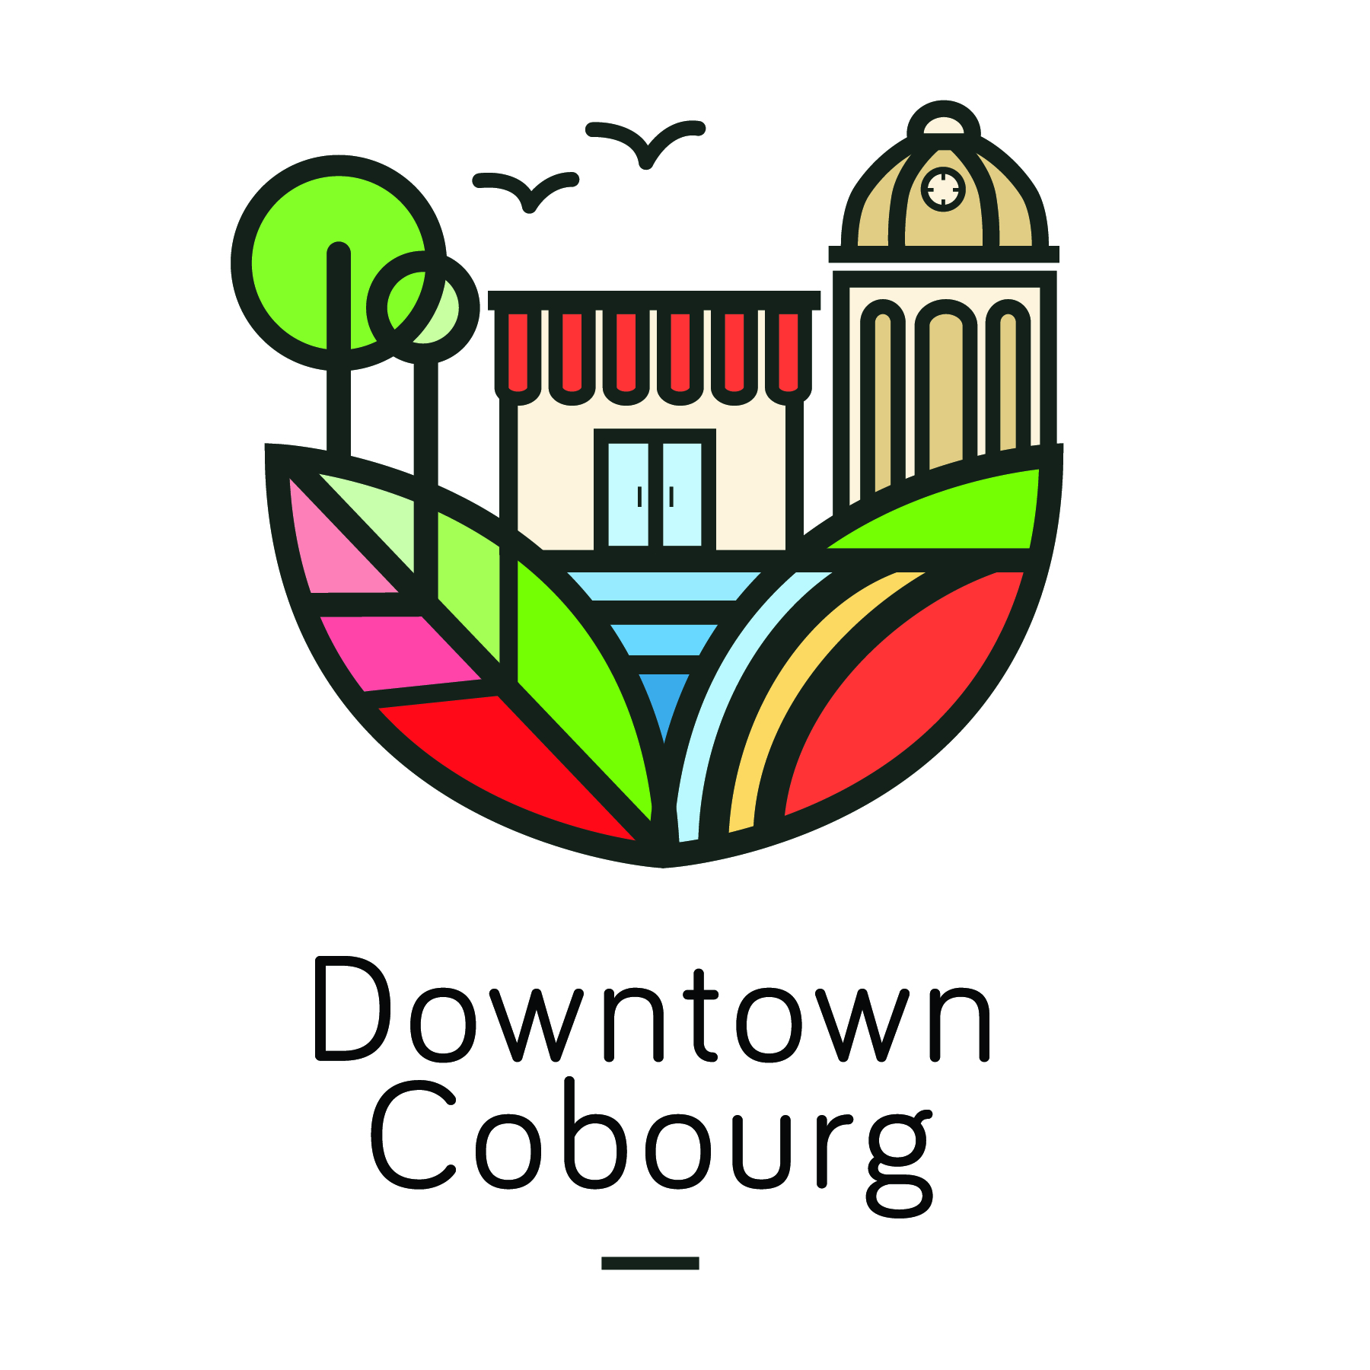

March 9, 2018
News Release
For Immediate Release
Shop to Win in Downtown Cobourg
COBOURG, ON – The Spring Passport Program is back with more places to shop for more chances to win! Pick up a passport at one of the participating locations and start collecting stamps for every $10 spent in downtown between Monday, March 19 and Sunday, April 30. Each passport serves as an invitation to shop local and explore Downtown Cobourg. With over 50 participating locations, there are many opportunities for you to fill your passport and enter it in for a chance to win.
“We are very excited to bring this initiative back,” says Paige Wiggans, Events and Communications Coordinator. “Last year we had 5,000 passports entered and we look forward to more entries this year with more locations to shop to win!”
Shoppers get over 40 days to collect stamps for a chance to win one of five gift certificates of $100 Downtown Dollars. Passports can be collected at any of the fifty-eight participating locations and counting!
Program Details:
- To participate, make a purchase at any of the participating businesses from March 19 to April 30, and have your passport stamped once for every $10 spent.
- When you have received 10 stamps, the passport is can be entered to win!
- Participants fill in their contact information and return the full passport to any participating business or the Cobourg DBIA office during the program.
- There is no limit on the number of passports a person can enter!
- Completed passports enter participants in a draw happening at Girl’s Night Out on Friday, May 11.
- There will be five $100 gift certificates of Downtown Dollars which can be redeemed at any participating locations.
For more information, and a complete list of the 2018 Calendar of Events in Downtown Cobourg, visit www.downtowncobourg.ca.
-30-
For more information, please contact:
Paige Montgomery, Event & Communications Coordinator
Cobourg Downtown Business Improvement Area
dbia@downtowncobourg.ca | (905)-377-8024

